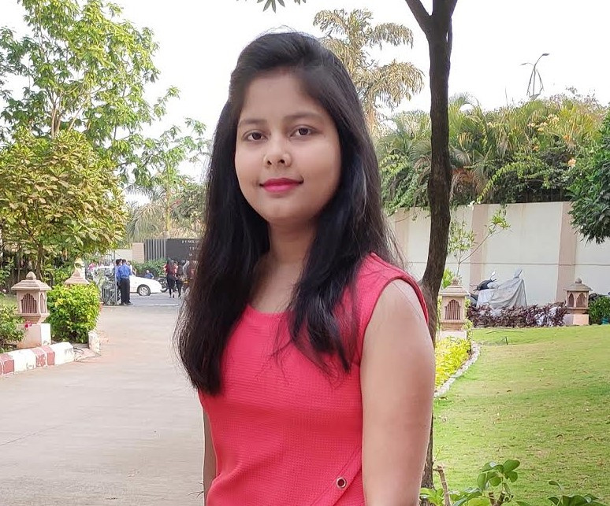

RITIKA KUMARI

AI & Data Science

PERSONAL PROFILE

Hi there, I'm Ritika Kumari, a third-year CSE   
student at D Y Patil International University. As   
a student of computer science engineering, I   
have good expertise and experience in various   
technical fields.

Ritika

TECHNICAL SKILLS

- Python & MySQL  
- Data Visualization using Power BI & Tableau- Data Analysis in MS Excel  
- Web Scrapping in Python  
- Web Development in HTML, CSS & PHP- Web Automation using selenium  
- AI and Machine Learning  
- Probability & Statistics

EDUCATIONAL HISTORY

D Y PATIL INTERNATIONAL UNIVERSITY CSE - Specialization in AI | Aug 2019 - July 2023

PRAKRITIK SCHOOL   
Intermediate in PCMB | Passed out in 2019

RNP PUBLIC SCHOOL   
Matriculation in Science & Maths | Passed in 2017

WORK EXPERIENCE

Web Development Intern   
The Sparks Foundation | June 2021 - July 2021

|  |  |  |
| --- | --- | --- |
| CHARACTERISTICAL SKILLS |  | Contributed with the lead to create a |
| web-based banking app. |

- Motivated, well-disciplined individual- Works constructively with the team- Can lead team to achieve goals  
- Effective Motivator and Negotiator- Communicate Effectively

 Used HTML, CSS & Javascript for making

the website.

PROJECTS

|  |  |  |
| --- | --- | --- |
| HOBBIES  - Painting & sketching - Watching movies (live action & animations) _ Listening music | Diabetes Predicting  DYPIU | Nov 2021 - Dec 2021 | |
|  | Performed EDA on the given dataset |
|  | Used keras for sequential modeling & |
| training the data | |
|  | And evaluated the model using the |

CONTACT ME AT   
Mobile Number: 7079234071

ritikakri935@gmail.com

Confusion matrix and ROC curve Neuroscience Data Analysis   
DYPIU | Jun 2021 - Jul 2021

 Studied real-world dataset of Parkinson’s Disease

 Performed data visualization & regression